Laryngeal Hypersensitivity
This leaflet is designed to provide an explanation of the role of the larynx, laryngeal sensitivity and factors that contribute to laryngeal hypersensitivity.

What is the larynx?
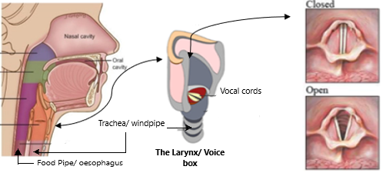
The larynx (aka voice box) is situated behind the Adams apple it is essential for:
Breathing- air travels through the larynx on the way to the lungs
Swallowing- the airway is closed off by the larynx so food/ drink can safely enter the food pipe. Muscles in the throat close when we swallow so food/ drink do not enter the wind pipe.
Coughing- if the larynx senses unwanted material (i.e. food, drink, smoke, etc) entering the airway it will trigger a cough, clashing the vocal chords together to eject the material from the wind pipe.
Communication- the vocal folds in the larynx vibrate gently to produce sound.
The tissue along the lining of your voice box is very sensitive. This helps your body detect material that is at risk of entering the airway. The tissue in the voce box needs to be well lubricated with mucus so food can slide into the food pipe and vocal chords can vibrate correctly.

What is laryngeal hypersensitivity?

Laryngeal hypersensitivity occurs when the larynx becomes too sensitive, this means the muscles respond to stimulants it usually wouldn’t notice. Examples include:
- A cough in response to cold air or strong smells.
- A constant sensation of mucus in the throat.
- feeling like your airway is shutting off.

Common Triggers
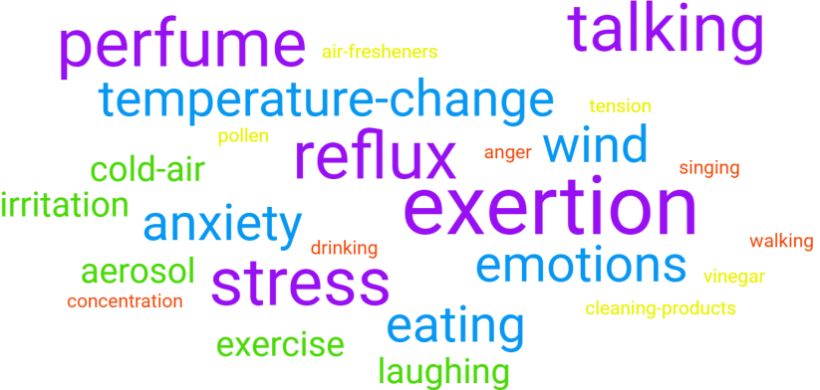

Disorders associated with laryngeal hypersensitivity
Persistent throat symptoms-feeling of excessive mucus in the throat/ lump in the throat when nothing is actually there.
Inducible Laryngeal obstruction- muscles in the throat close during respiration causing breathlessness/ a choking sensation.
Chronic cough- an unexplained dry cough lasting more than 8 weeks, often linked to throat irritation.
Dysphonia- Trouble with the voice when trying to talk. This may be described as hoarseness or poor voice quality.
Your speech and language therapist will be able to discuss, diagnose and treat these conditions.

Why do I have laryngeal hypersensitivity?
Certain factors can make some people more likely to experience laryngeal hypersensitivity. These can be linked to medical factors, life events and exposure to irritants. It is unclear exactly what causes laryngeal hypersensitivity, however, some key risk factors are:
- Upper airway infections, i.e. colds & flus.
- Dehydration
- coughing/ throat clearing
- Stress/anxiety

People rarely have only one contributing factor, it is usually a combination of several.
- Medication
- Trauma
- Reflux
- Asthma
- COPD
- Smoking
- Focusing in on sensations in the throat

Please help us develop our service:



