Policy for the Prescription and Administration of
Oxygen in Adults
Classification: Policy
Lead Author: ******
Consultant in Respiratory Medicine

Additional author(s):
**** Physiotherapist
****** Respiratory Nurse Specialist
***** Pharmacist
(Based on BTS Guideline for oxygen use in healthcare and emergency settings 2017)
Authors Division: ******
Unique ID: *******
Issue number: ****
Date approved: 2017

1.0 Who should read this document? 3
2.0 Key Messages 3
3.0 Background & Scope 3
4.0 What is new in this version? 3
5.0 PROTOCOL, STANDARDS AND ROLES AND RESPONSIBILITIES - Prescribing, administering and monitoring oxygen 4
6.0 Exclusions 6
7.0 Specialist Areas (including Emergency Deptartment PGD) 6
8.0 Indications 7
9.0 Contra-indications 7
10. Cautions 7
11. Transfer and transportation of patients receiving oxygen 8
12. Peri-operative and immediately post operatively 8
13. Nebulised therapy and oxygen 8
14. Normal Oxygen saturation ranges 8
15. Summary of Oxygen Administration protocol (and weaning protocol) 9
16. Humidification 10
17. Health and Safety issues are covered in Appendix (o). 11
18. Explanation of terms & Definitions 11
19. References and Supporting Documents 11
20. Appendices 11
Appendix (a) Table 1 Critical illnesses requiring high levels of supplemental oxygen 12
Appendix (b) Table 2 Serious illnesses requiring moderate levels of supplemental oxygen if the patient is hypoxaemic 13
Appendix (c) Table 3 COPD and other conditions requiring controlled or low-dose oxygen 14
Appendix (d) Table 4 Conditions for which patients should be monitored closely but oxygen therapy is not required unless the patient is hypoxaemic. 15
Appendix (e) Chart 1 Oxygen prescription for acutely hypoxaemic patients 16
Appendix (f) Illustration of Oxygen prescribing at this Trust 17
Appendix (g) ADMINISTERING ACUTE OXYGEN THERAPY 18
Appendix (h) EQUIPMENT USED IN THE DELIVERY OF OXYGEN (Choose the appropriate delivery device) 19
Appendix (i) Flow chart for oxygen administration on general wards 27
Appendix (j) PERSONNEL WHO MAY ADMINISTER OXYGEN 28
Appendix (k) – Bedside Observation Chart* (this is the respiratory section) and abbreviation codes for oxygen delivery devices 28
Appendix (l) MONITORING OF PATIENTS See Trust policy and NEWS system 29
Appendix (m) Trust Early Warning Score parameters and scoring system 30
Appendix (n) HUMIDIFICATION 31
Appendix (o) HEALTH AND SAFETY 31
Document Control Information 32
Policy Implementation Plan 32
Monitoring and Review 33
Endorsement 34
Screening Equality Analysis Outcomes 35

1.0 Who should read this document?

This is a Trustwide policy to guide the safe and effective prescribing and administration of oxygen in Adults. Therefore all clinical staff involved with the administration of oxygen therapy must read this policy.

2.0 Key Messages

The aim of this protocol is to ensure that:

All patients who require supplementary oxygen therapy receive therapy that is appropriate to their clinical condition and in line with national guidance (British Thoracic Society [BTS] Guideline 2017).
- Oxygen will be prescribed according to a target saturation range. The system of prescribing target saturation aims to achieve a specified outcome, rather than specifying the oxygen delivery method alone.
- Those who administer oxygen therapy will monitor the patient and keep within the target saturation range.

3.0 Background & Scope

This policy will ensure that all patients who require oxygen are given the correct amount of oxygen using the most appropriate equipment. The administration of supplemental oxygen is an essential element of appropriate management for a wide range of clinical conditions; however oxygen is a drug and therefore requires prescribing in all but emergency situations. Failure to administer oxygen appropriately can result in serious harm to the patient. The safe implementation of oxygen therapy with appropriate monitoring is an integral component of the Healthcare Professional’s role.

The guideline is based on the British Thoracic Society (BTS) Guideline for oxygen use in adults in healthcare and emergency settings 2017

4.0 What is new in this version?

All references are to 2017 BTS Guideline which replaces the 2008 Guideline.
There are other minor alterations to the policy but no substantive changes.

5.0 PROTOCOL, STANDARDS AND ROLES AND RESPONSIBILITIES - Prescribing, administering and monitoring oxygen

5.1 Identifying appropriate target saturations
Guidance on identifying appropriate saturations for patients is provided for the medical staff and other prescribers in Appendices a-e (table 1-4 and figure 1 in the guideline). In summary oxygen should be prescribed to achieve a target saturation range of 94-98% for most acutely unwell patients or 88-92% for those at risk of hypercapnic respiratory failure.

5.2 Prescribing oxygen – all patients should have a target range
*This section is written for electronic prescribing- modify if your Trust uses paper*
The oxygen prescription template in the Electronic Patient Record has been designed to assist clinicians with the prescription and administration of oxygen. To prescribe oxygen type “Oxygen” into the EPR “Enter Order” tab as shown in Appendix f. Any patient in the hospital could develop an illness or complication leading to the development of hypoxaemia (low blood oxygen level). For this reason, it is Trust policy that all patients should have a target saturation range established on admission to hospital so that the first responders will be aware of the patient’s needs if they should develop hypoxaemia due to acute illness. Oxygen can be prescribed conveniently at the time of admission to hospital using the “Admissions bundle” accessed via the EPR orders tab. This allows the efficient prescription of oxygen at the same time as thromboprophylaxis and MRSA risk management.

5.3 Administering oxygen
Once the target saturation has been identified and prescribed, guidance regarding the most appropriate delivery system to reach and maintain the prescribed saturation is provided for those administering oxygen in Appendix e, f, g, h and i. Personnel who may administer oxygen is shown in Appendix (j).

5.4 Monitoring and recording oxygen
The patient's oxygen saturation and oxygen delivery system should be recorded on the bedside observation chart or in the EPR observations section alongside other physiological variables as shown in Appendix (k). This appendix also specifies the codes for oxygen delivery devices to be recorded on the observation chart. Patients should thus be monitored as specified in Appendix (l).

All patients on oxygen therapy should have regular pulse oximetry measurements. The frequency of oximetry measurements will depend on the condition being treated and the stability of the patient. Critically ill patients should have their oxygen saturations monitored continuously and recorded every few minutes whereas patients with a stable condition will need less frequent monitoring.

Oxygen therapy should be increased if the saturation is below the desired range and decreased if the saturation is above the desired range (and eventually discontinued as the patient recovers). See section 13 and Appendix (i) for more details

Any sudden fall in oxygen saturation should lead to clinical evaluation of the patient and in most cases, measurement of blood gases.

Patients on oxygen should have their saturations recorded in line with the Trust’s minimum observation policy. (See Appendix l and Appendix m)

Patients should be monitored accurately for signs of improvement or deterioration. Nurses should also monitor skin colour for peripheral cyanosis and respiratory rate.
It is sometimes possible to obtain an oximetry signal from the earlobe if the circulation in the fingers is poor. Unexpected low or high oxygen saturations contribute to the Trust, Early Warning System as illustrated in Appendix. (m).
• If a patient has elevated EWS because of saturation below the target range, the nurse should increase the concentration or flow of oxygen and discuss the patient with a doctor and monitor the saturation on the new higher dose of oxygen.
• If a patient has elevated EWS purely because of being on oxygen with saturation above target range but is otherwise clinically stable, the nurse should reduce the concentration or flow of oxygen and repeat the EWS measurement after about 5 minutes. It is not necessary to call a doctor to assess the patient just to reduce the oxygen saturation into the desired range if there are no clinical concerns.

5.5 Emergency situations

In the emergency situation an oxygen prescription is not required. Oxygen should be given to the patient immediately without a formal prescription or drug order but documented later in the patient’s record.

All critically ill patients should be given 100% oxygen (15 l/m reservoir mask) whilst awaiting immediate medical review. Patients with COPD and other risk factors for hypercapnia who develop critical illness should have the same initial target saturations as other critically ill patients pending the results of urgent blood gas results after which these patients may need controlled oxygen therapy or supported ventilation if there is severe hypoxaemia and/or hypercapnia with respiratory acidosis.

All patients who have had a cardiac or respiratory arrest should have 100% Oxygen provided along with basic/advanced life support until return of spontaneous circulation and reliable oximeter readings are achieved. (See 2015 Resuscitation Council UK Guideline).

A subsequent written record must be made of what oxygen therapy has been given to every patient alongside the recording of all other emergency treatment.

Any qualified nurse/ health professional can commence oxygen therapy in an emergency situation as indicated in the trust policy on Management of the Acutely Unwell Patient.

5.6 Policy Implementation Plan

****, Consultant Respiratory Physician and Oxygen Champions; **** (Physiotherapy), **** (Pharmacy) and **** (Respiratory Nurse specialist) are responsible for implementing this policy and keeping a detailed implementation plan

The medicines management group and Respiratory Clinical Governance Meetings will take responsibility for reviewing progress in implementing the plan

The original Trust Oxygen policy was implemented and deployed in 20**. The current revision updates the policy in line with the 2017 BTS guideline for oxygen use in healthcare and emergency settings. There are learning resources for doctors and nurses available on the BTS Website.

6.0 Exclusions

• Patients admitted to specialist areas with a specialised oxygen prescribing policy (see section 7 of this policy document)

• Patients receiving oxygen as part of palliative care or patients on the end of life care pathway (in which case, the prescriber should indicate that a target saturation is not required).

• Patients admitted for Long Term Oxygen Therapy assessment.

7.0 Specialist Areas (including Emergency Department Oxygen PGD)

This policy is for general use within general wards and departments. Where specific clinical guidelines are required for oxygen administration within specialist areas, they must be approved via the appropriate clinical governance forum. They should reflect wherever possible the principles within this policy. Patients transferring from specialist areas must be transferred with a prescription for their oxygen therapy utilising target saturation, if the clinical indication is ongoing. If a patient transfers from an area not utilising the target saturation system, their oxygen should be administered as per the transferring area’s prescription until the patient is reviewed and transferred over to the target saturation scheme, which should occur as soon as possible.
Patients requiring oxygen in the Emergency Department prior to medical review should be treated in accordance with the Emergency Department Oxygen PGD (Patient Group Direction) which is available on the Trust Intranet.
This item (PGD) may not be available in all Trusts- delete if not applicable but ensure that there is an effective policy in the Emergency Department.

8.0 Indications

The rationale for oxygen therapy is prevention of cellular hypoxia, caused by hypoxaemia (low PaO₂), and thus prevention of potentially irreversible damage to vital organs.

Therefore the most common reasons for oxygen therapy to be initiated are:

- Acute hypoxaemia (for example pneumonia, shock, asthma, heart failure, pulmonary embolus, sepsis)
- Ischaemia (for example myocardial infarction, but only if associated with hypoxaemia (abnormally high blood oxygen levels may be harmful to patients with ischaemic heart disease and stroke).
- Abnormalities in quality or type of haemoglobin (for example acute GI blood loss or carbon monoxide poisoning).

Other indications include:

- Pneumothorax – Oxygen may increase the rate of resolution of pneumothorax in patients for whom a chest drain is not indicated.
- Post operative state (general anaesthesia can lead to decrease in functional residual capacity with in the lungs (especially following thoracic or abdominal surgery) resulting in hypoxaemia (Ferguson 1999). However, it is preferable to specify target saturation and only administer oxygen if the patient is hypoxaemic.

9.0 Contra-indications

There are no absolute contraindications to oxygen therapy if indications are judged to be present. The goal of oxygen therapy is to achieve adequate tissue oxygenation using the lowest possible FiO₂. Supplemental oxygen should be administered with caution in patients suffering from paraquat poisoning (BNF 2005) and with acid inhalation or previous bleomycin lung injury.

10. Cautions

10.1. Oxygen administration and carbon dioxide retention (Type 2 Respiratory Failure)

In patients with chronic carbon dioxide retention, oxygen administration may cause further increases in carbon dioxide and respiratory acidosis. This may occur in patients with COPD, neuromuscular disorders, morbid obesity or musculoskeletal disorders. There are several factors which lead to the rise in CO2 with oxygen therapy in patients with hypercapnic respiratory failure and details are in the BTS guideline.

10.2. Other precautions/ Hazards/ Complications of oxygen therapy

• Drying of nasal and pharyngeal mucosa
• Oxygen toxicity
• Absorption atelectasis
• Skin irritation
• Fire hazard
• Potentially inadequate flow resulting in lower FiO₂ than intended due to high inspiratory demand or inappropriate oxygen delivery device or equipment faults

10.3 Oxygen tubing and oxygen wall outlets
Oxygen tubing is needed to connect flow meters and regulators to the patient delivery device. It is important to ensure that all tubing is connected correctly at both ends. The National Patient Safety Agency has reported frequent adverse events related to oxygen use, including four reports of instances where an oxygen mask was connected in error to a compressed air outlet instead of an oxygen outlet. Compressed air outlets are often used to drive nebulisers in hospitals because they are quieter than electrical compressors. However, the flow meter looks very similar to an oxygen flow meter and is often mounted beside an oxygen flow meter so it is very important to ensure that air flow meters are clearly labelled. Air flow meters are never required in an emergency and should be removed from wall sockets or covered by a designated ‘‘hood’’ when not in use, an example is shown below. There have also been cases where twin oxygen outlets were in use and the wrong one had been turned on or off. For example, one patient tried to turn off the oxygen flow after finishing a nebulised treatment but accidentally turned off the oxygen flow to a neighbouring patient with serious consequences. It is recommended that patients should not be allowed to adjust oxygen flow, especially if there are dual outlets.
- Air flow meters should be removed from the wall sockets or covered with a designated air outlet cover when not in use. Special care should be taken if twin oxygen outlets are in use
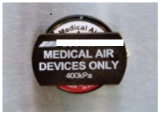Air outlet cover

11. Transfer and transportation of patients receiving oxygen

Patients who are transferred from one area to another must have clear documentation of their ongoing oxygen requirements and documentation of their oxygen saturations. Staff must ensure that adequate oxygen is provided during transfers and whilst patients are in diagnostic departments. Oxygen saturation should be monitored continuously by registered healthcare professionals for seriously ill patients who require escorted transfers.

Patients who are medically unstable and those requiring high dose oxygen therapy (Reservoir mask, Venturi mask above 35% or Humidified oxygen above 35% or nasal or simple mask above 5 l/min) whilst being transferred from one area to another should be accompanied by a registered healthcare professional. HCA staff may transfer stable patients with low Early Warning Score who are on low dose oxygen.
Clear instructions must be provided for personnel involved in the transfer of the patient, which must include delivery device and flow rate.
Staff must ensure there are adequate numbers of oxygen cylinders are that they are full when they leave the department/ward.

If a patient transfers from an area not utilising the target saturation system (see specialist areas above) their oxygen should be administered as per the transferring areas prescription until the patient is reviewed and transferred over to the target saturation scheme, which should occur as soon as possible.

12. Peri-operative and immediately post operatively

The usual procedure for prescribing oxygen therapy in these areas should be adhered to, utilising the target saturation. If a patient is transferred back to the ward on oxygen therapy and is not on the target saturation system, the need for ongoing oxygen therapy should be reviewed as soon as possible. If oxygen therapy is to be continued, it should be prescribed using the target saturation scheme unless there is an alternative time-limited instruction which is part of the Trust’s Post-Operative care policy for selected patients.

13. Nebulised therapy and oxygen

When nebulised therapy is administered to patients at risk of hypercapnic respiratory failure (see section 8.1), it should be driven by compressed air. If necessary, supplementary oxygen should be given concurrently by nasal prongs at 1-4 litres per minute to maintain an oxygen saturation of 88-92% or other specified target range.

All patients requiring 35% or greater oxygen therapy should have their nebulised therapy by oxygen at a flow rate of >6 litres/minute.

14. Normal Oxygen saturation ranges

• In adults less than 70 years of age at rest at sea level 96% - 98% when awake.
• Aged 70 and above at rest at sea level 94%-98% when awake.
• Patients of all ages may have transient dips of saturation to 84% during sleep.

15. Summary of Oxygen Administration protocol (and weaning protocol)

Action | Rationale
All patients requiring oxygen therapy will have a prescription for oxygen therapy recorded on the electronic drug prescription system. N.B exceptions- see emergency situations | Oxygen should be regarded as a drug and should be prescribed. BTS National guidelines (2017). British National Formulary (2016).
The prescription will incorporate a target saturation that will be identified by the clinician prescribing the oxygen in accordance with the Trust's oxygen guideline | Certain groups of patients require different target ranges for their oxygen saturation, see Tables 1-4.  Certain groups of patients are at risk of hyperoxaemia, particularly patients with COPD.
The prescription will incorporate an initial starting dose (i.e. delivery device and flow rate) | To provide the nurses with guidance for the appropriate starting point for the oxygen delivery system and flow rate
The drug chart should be signed electronically at every drug round | The clinical observations chart should be reviewed at every drug round and the drug chart should be signed electronically to indicate that the patients is within target, or appropriate action has been taken if not, or else indicate that the patient is breathing air.
Once oxygen is in situ the nurse will monitor observations in line with trust policy. All patients should have their oxygen saturation observed for at least five minutes after starting oxygen therapy. If a patient is receiving intermittent therapy they must be monitored at least 8 hourly. | To identify if oxygen therapy is maintaining the target saturation or if an increase or decrease in oxygen therapy is required
The oxygen delivery device and oxygen flow rate should be recorded alongside the oxygen saturation on the bedside observation chart. | To provide an accurate record and allow trends in oxygen therapy and saturation levels to be identified.
Oxygen saturations must always be interpreted alongside the patient’s clinical status incorporating the early warning score. | To identify early signs of clinical deterioration, e.g. elevated respiratory rate
If the patient falls outside of the target saturation range, the oxygen therapy will be adjusted accordingly  The saturation should be monitored continuously for at least 5 minutes after any increase or decrease in oxygen dose to ensure that the patient achieves the desired saturation range. | To maintain the saturation in the desired range.
Saturation higher than target specified or >98% for an extended period of time.

- Step down oxygen therapy as per guidance for delivery | The patient will require weaning down from current oxygen delivery system.  See Appendix (i)
- Consider discontinuation of oxygen therapy | The patients clinical condition may have improved negating the need for supplementary oxygen
Saturation lower than target specified
- Check all elements of oxygen delivery system for faults or errors. | In most instances a fall in oxygen saturation is due to deterioration of the patient however equipment faults should be checked for.
- Step up oxygen therapy as per protocols in appendix (i). Any sudden fall in oxygen saturation should lead to clinical evaluation and in most cases measurement of blood gases | To assess the patients response to oxygen increase, and ensure that PaCO2 has not risen to an unacceptable level, or pH dropped to an unacceptable level and to screen for the cause of deteriorating oxygen level (e.g. pneumonia, heart failure etc)
- Monitor Early Warning Score and respiratory rate for further clinical signs of deterioration | Patient safety
Saturation within target specified
- Continue with oxygen therapy, and monitor patient to identify appropriate time for stepping down therapy, once clinical condition allows
- A change in delivery device (without an increase in O2 therapy) does not require review by the medical team. | (The change may be made in stable patients due to patient preference or comfort).
Oxygen delivery methods
The Trusts recommended that specified delivery devices should be utilised to ensure a standardised approach to oxygen delivery, see Appendix (h) | Previous audits have demonstrated wide variations in delivery devices across clinical areas, potentially increasing the risk of adverse incidents

16. Humidification
Humidification may be required for some patient groups, especially “neck-breathing patients” and those who have difficulty in clearing airway secretions or mucus. See Appendix (n).

17. Health and Safety issues are covered in Appendix (o).

18. Explanation of Terms & Definitions

Terms explained in the document.

19. References and Supporting Documents

- BTS Guideline for oxygen use in adults in healthcare and emergency settings, O’Driscoll BR et al Thorax 2017; 72: Suppl 1 i1-i89
- Summary guideline for prescribing oxygen emergency oxygen in hospital. Available on BTS website: https://www.brit-thoracic.org.uk/standards-of-care/guidelines/bts-guideline-for-emergency-oxygen-use-in-adult-patients/
- Summary of prescription, administration and discontinuation of oxygen therapy. Available on BTS website: https://www.brit-thoracic.org.uk/standards-of-care/guidelines/bts-guideline-for-emergency-oxygen-use-in-adult-patients/

20. Appendices

APPENDICES ARE SHOWN ON THE FOLLOWING PAGES

Appendix (a) Table 1 Critical illnesses requiring high levels of supplemental oxygen

Table 1 Critical illnesses requiring high levels of supplemental oxygen
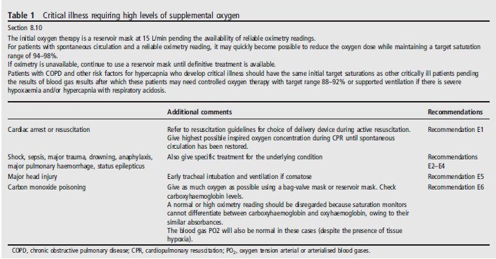

Appendix (b) Table 2 Serious illnesses requiring moderate levels of supplemental oxygen if the patient is hypoxaemic
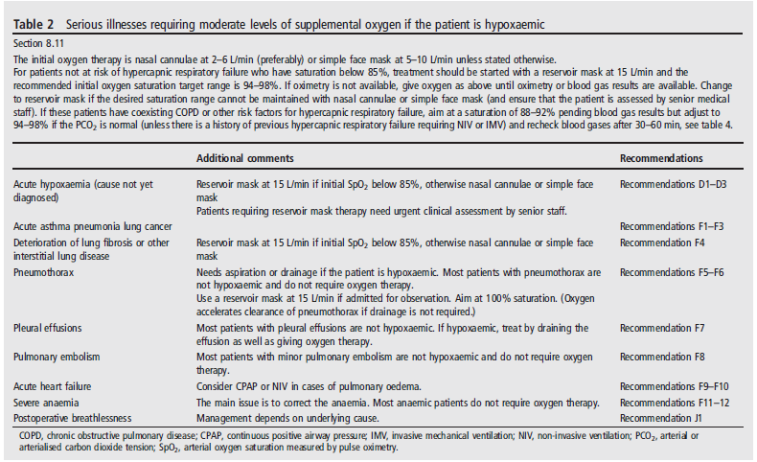

Appendix (c) Table 3 COPD and other conditions requiring controlled or low-dose oxygen
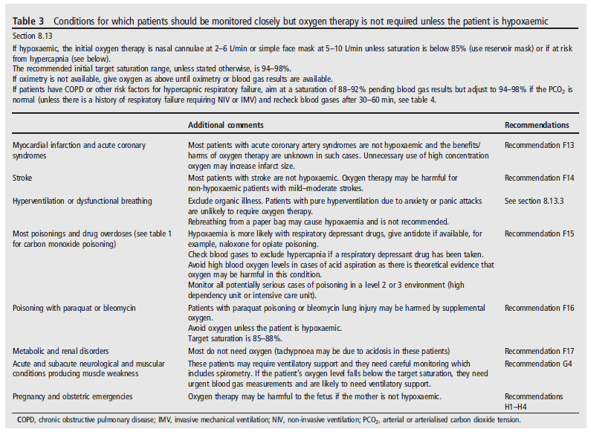

Appendix (d) Table 4 Conditions for which patients should be monitored closely but oxygen therapy is not required unless the patient is hypoxaemic.
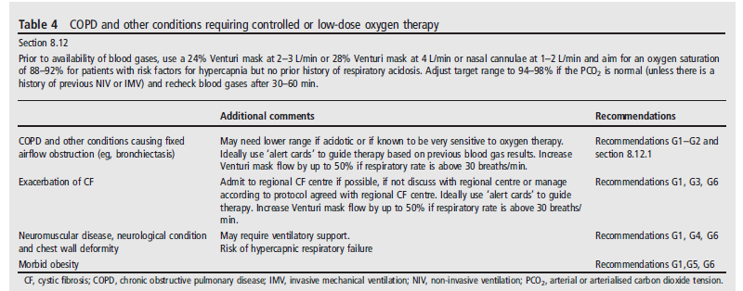

Appendix (e) Chart 1 Oxygen prescription for acutely hypoxaemic patients

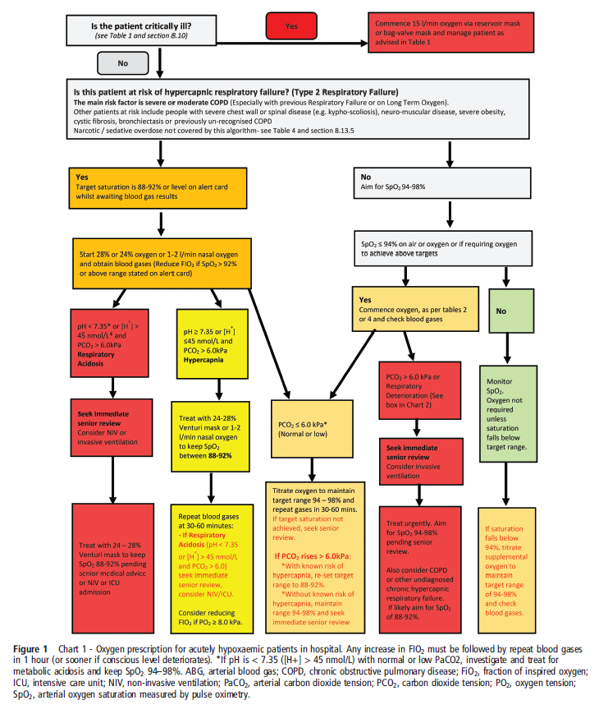

Appendix (f) Illustration of Oxygen prescribing in Trust Electronic medicines prescription system Insert an example from your own Trust here

1. Click on the Orders box and type “Oxygen” (or use “Admissions Bundle)
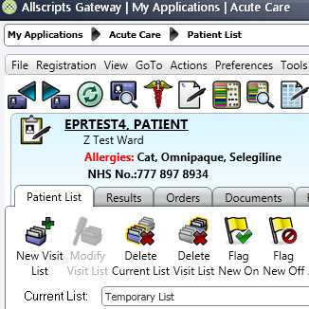

2. Prescribe an appropriate oxygen target range for your patient
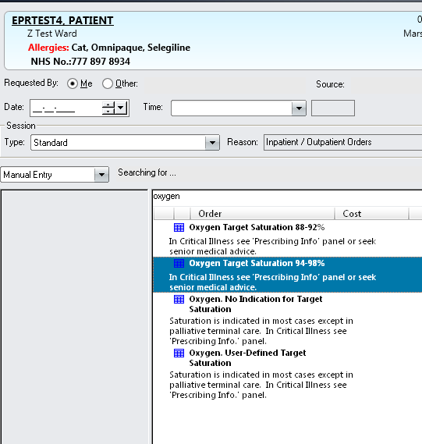

Appendix (g) ADMINISTERING ACUTE OXYGEN THERAPY

ACTION | RATIONALE
1. Ensure patency of airway | To promote effective oxygenation
2. The type of delivery system used will depend on the needs and comfort of the patient. It is the nurses role to assess the patient and use the prescribed system. | To provide accurate oxygen delivery. Most stable patients prefer nasal cannulae to masks.
3. Ensure oxygen is prescribed (usually in EPR but otherwise on paper).  In some situations a protocol may be in place to allow designated nurses to administer oxygen.  In these cases the doctor must review the patient’s condition within the stated time and prescribe oxygen accordingly. | To ensure a complete record is maintained and expedite patient treatment. The exception to this action would be during an emergency situation where the resuscitation guideline should be followed.
4. Ensure that the oxygen dose is clearly indicated. If nasal cannula or reservoir masks are being used check that the flow rate is clearly indicated. | In accordance with the administration of medicines policy.
5. Inform patient and or relative/ carer of the combustibility of oxygen. | Oxygen supports combustion therefore there is always a danger of fire when oxygen is being used.
6. Show and explain the oxygen delivery system to the patient. Give the patient the information sheet about oxygen. | To obtain consent and cooperation.
7. Assemble the oxygen delivery system carefully as shown in Appendix (h). | To ensure oxygen is given as prescribed.
8. Attach oxygen delivery system to oxygen source. | To ensure oxygen supply is ready
9. Attach oxygen delivery system to patient according to manufacturer’s instructions. | For oxygen to be administered to patient.
10. Turn on oxygen flow in accordance with prescription and manufacturers instruction. | To administer correct amount of oxygen.
11. Ensure patient has either a drink or mouthwash within reach. | To prevent drying of the oral mucosa
12. Clean oxygen mask as required general purpose detergent and dry thoroughly needed. Discard systems after use. | To minimise risk of infection  (Single patient device)

Appendix (h) EQUIPMENT USED IN THE DELIVERY OF OXYGEN (Choose the appropriate delivery device)
- Oxygen source (piped or cylinder)
- Flow meter
- Saturation monitor
- Oxygen Delivery system - (see appendix j for advice on use of each device);

h1) Nasal cannula
DEVICE | DESCRIPTION |  | PURPOSE
Nasal Cannulae  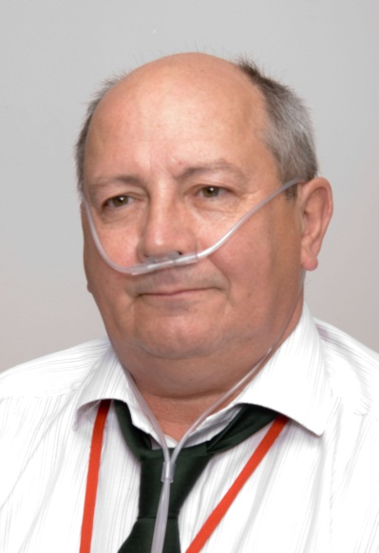 | Nasal cannulae consist of pair of tubes about 2cm long, each projecting into the nostril and stemming from a tube which passes over the ears and which is thus self-retaining.  Uncontrolled oxygen therapy  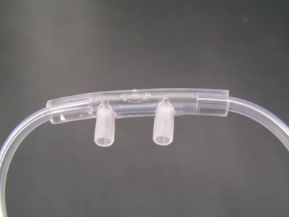 |  | Cannulae are preferred to masks by most patients. They have the advantage of not interfering with feeding and are not as inconvenient as masks during coughing and sneezing.  It is not advisable to assume what percent oxygen (FI02) the patient is receiving according to the Litres delivered but this is not important if the patient is in the correct target range.
ACTION |  | RATIONALE
- (When using nasal cannula).  Position the tips of the cannula in the patient’s nose so that the tips do not extend more than 1.5cm into the nose. |  | Overlong tubing is uncomfortable, which may make the patient reject the procedure. Sore nasal mucosa can result from pressure or friction of tubing that is too long.
Place tubing over the ears and under the chin as shown above. Educate patient re prevention of pressure areas on the back of the ear. |  | To allow optimum comfort for the patient.  To prevent pressure sores.
3. Adjust flow rate, usually 2-4 l/min but may vary from 1-6 l/min in some circumstances. |  | Set the flow rate to achieve the desired target oxygen saturation.

h2) Fixed performance mask (Venturi mask and valve)
DEVICE | DESCRIPTION |  | PURPOSE
Venturi mask  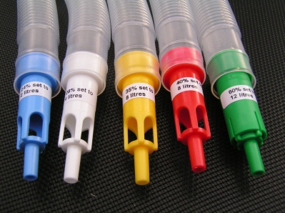 | A mask incorporating a device to enable a fixed concentration of oxygen to be delivered independent of patient factors or fit to the face or flow rate. Oxygen is forced out through a small hole causing a Venturi effect which enables air to mix with oxygen.  Controlled oxygen therapy |  | This is a high performance oxygen mask designed to deliver a specified oxygen concentration regardless of breathing rate or tidal volume.  Venturi devices come in different colours for %  Blue = 24%  White = 28%  Yellow = 35%  Red = 40%  Green = 60%
ACTION |  | RATIONALE
1. (When using Venturi mask)  Connect the mask to the appropriate Venturi barrel attached firmly into the mask inlet. |  | To ensure that patient receives the correct concentration of oxygen
2.Fasten oxygen tubing securely. |  | Correctly secured tubing is comfortable and prevents displacement of mask/cannulae.
3.Assess the patient’s condition and functioning of equipment at regular intervals according to care plan. |  | To ensure patient’s safety and that oxygen is being administered as prescribed.
4. Adjust flow rate. The minimum flow rate is indicated on the mask or packet. The flow should be doubled if the patient has a respiratory rate above 30 per minute. |  | Higher flows are required for patients with rapid respiration and high inspiratory flow rates. This does not affect the concentration of oxygen but allows the gas flow rate to match the patient’s breathing pattern.

h3) Simple face mask (variable flow)

DEVICE  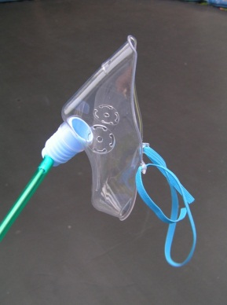 | DESCRIPTION  Mask has a soft plastic face piece, vent holes are provided to allow air to escape.  Maximum 50%-60% at 15ltrs/minute flow. |  | PURPOSE  This is a variable performance device. The oxygen concentration delivered will be influenced by:  a. the oxygen flow rate( litres per minute) used, leakage between the mask and face;
Simple face mask  Variable Percentage  (Delivers unpredictable concentrations that vary with flow rate)  Nasal cannulae should be used for most patients who require medium dose oxygen but a simple face mask may be used due to patient preference or if the nose is blocked | Uncontrolled Oxygen therapy |  | b. the patient’s tidal volume and breathing rate.  NOT to be used for CO₂ retaining patients.
ACTION |  | RATIONALE
(If using simple face mask) Gently place mask over the patient’s face, position the strap behind the head or the loops over the ears then carefully pull both ends through the front of the mask until secure. |  | Ensure a comfortable fit and delivery of prescribed oxygen is maintained.
Check that strap is not across ears and if necessary insert padding between the strap and head.  Adjust the oxygen flow rate. Must never be below 5L/min |  | To prevent irritation.  Flows below 5L/m may not give enough oxygen and cause increased resistance to breathing, particularly if the patient has a high inspiratory flow rate, and may also cause CO2 re-breathing due to insufficient wash-out of expired gases from the mask

h4) Reservoir mask (non re-breathe mask)

DEVICE | DESCRIPTION | PURPOSE
Reservoir Mask  (Non-rebreathe Mask)  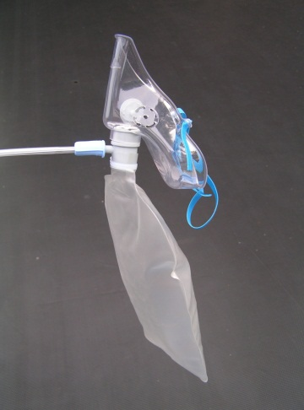 | Mask has a soft plastic face piece with flap-valve exhalation ports which may be removed for emergency air-intake. There is also a one-way valve between the face mask and reservoir bag.  Uncontrolled oxygen therapy | In non re-breathing systems the oxygen may be stored in the reservoir bag during exhalation by means of a one-way valve. High concentrations of oxygen 80-90% can be achieved at relatively low flow rates.  NOT to be used for C02 retaining patients except in life-threatening emergencies such as cardiac arrest or major trauma.
ACTION | RATIONALE
1. (Non Rebreathe Reservoir Mask)  Ensure the reservoir bag is inflated before placing mask on patient, this can be maintained by using 10-15 litres of oxygen per min. | To ensure the optimal flow of oxygen to the patient.
2. Adjust the oxygen flow to the prescribed rate. | Inadequate flow rates may result in administration of inadequate oxygen concentration to the patient.

In disposable reservoir, oxygen flows directly into the mask during inspiration and into the reservoir bag during exhalation. All exhaled air is vented through a port in the mask and a one-way valve between the bag and mask, which prevents re-breathing.

h5) Tracheostomy mask for patients with tracheostomy or laryngectomy

DEVICE  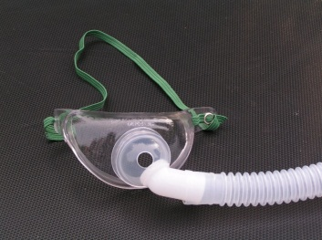 | DESCRIPTION  Mask designed for “neck breathing patients”. Fits comfortably over tracheostomy or tracheotomy. Exhalation port on front of mask. |  | PURPOSE  This is a variable performance device for patients with tracheostomy or tracheotomy. The oxygen concentration delivered will be influenced by:  a. the oxygen flow rate( litres per minute) used.  b. the patient’s tidal volume and breathing rate.
Tracheostomy mask  Variable Percentage  (Delivers unpredictable concentrations that vary with flow rate) | Uncontrolled Oxygen therapy |  | Use cautiously at low flow rates in CO2 retaining patients as there may be no alternative.
ACTION |  | RATIONALE
Gently place mask over the patient’s airway, position the strap behind the head then carefully pull both ends through the front of the mask until secure. |  | Ensure a comfortable fit and delivery of prescribed oxygen is maintained.
Adjust the oxygen flow rate to  achieve the desired target  saturation range. Start at 4 l/min  and adjust the flow up or down  as necessary to achieve the  desired oxygen saturation range. |  | To ensure that the correct amount of oxygen is given to keep the patient in the target range.

h6) Oxygen Flow Meter
DEVICE  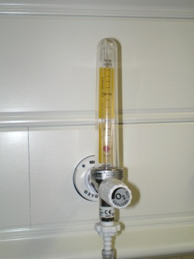  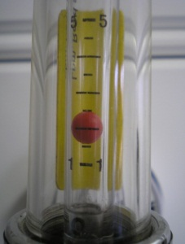 | DESCRIPTION  Device to allow the patient to receive an accurate flow of oxygen, usually between 2 and 15 litres per minute.  May be wall-mounted or on a cylinder.  Take special care when using twin oxygen outlets or if there are air outlets which may be mistaken for oxygen outlets. |  | PURPOSE  To ensure that the patient receives the correct amount of oxygen.  Correct Setting for 2 l/min
Oxygen flow meter
Delivers oxygen to the patient.

ACTION |  | RATIONALE
Attach the oxygen tubing to the  nozzle on the flow meter.  Turn the finger-valve to obtain the desired flow rate. The CENTRE of the ball shows the correct flow rate. The diagrams shows the correct setting to deliver 2 l/min. |  | To ensure that the patient receives the correct amount of oxygen.

h7) High Flow Nasal cannula

DEVICE DESCRIPTION

High Flow nasal cannula
Soft nasal cannula which delivers heated humidified oxygen through a blended oxygen delivery system such as Dragar.
There are therefore 3 components:
a patient interface,
a gas delivery device(s) to control flow and F_{IO2}
a humidifier.
The nasal prongs are held in place on the upper lip with an elastic over-ear head band. There is a larger diameter flex tubing proximal to the prongs and an around-the-neck elastic that connects to support the weight of the connecting tubing. They are available in large, medium, and small sizes

Used in level two and above (Critical care, SHDU, MHDU, NHDU)

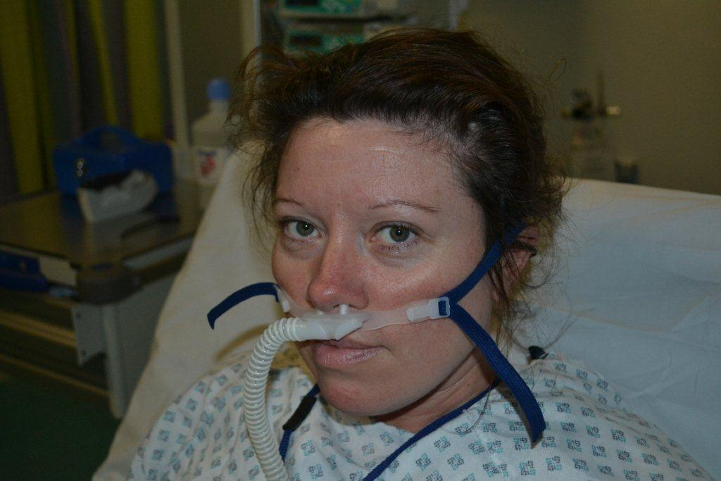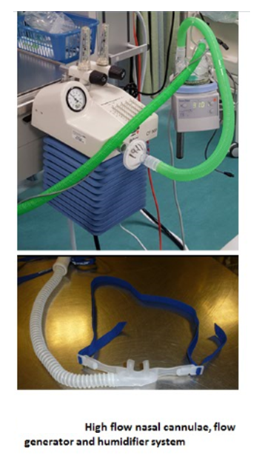

Controlled oxygen therapy
The oxygen is generally delivered in flow rates in excess of 30L /min therefore providing controlled oxygen therapy
The flow rate however can be reduced as the patient improves, therefore at rates below 30L/min the flow will be insufficient to deliver oxygen to meet the patients peak inspiratory flow and the oxygen concentration will therefore become variable.

PURPOSE
The HFNC can effectively be used to treat patients with moderate levels of hypoxemic respiratory failure.
HFNC could be considered as an initial appliance in certain settings (eg, ED), as flow could be titrated based on response over a full range without having to change to other devices. It could also be viewed as an alternative delivery interface for situations in which hypoxemia or dyspnea was not corrected after a trial of low-flow cannula, NRB and/or air-entrainment mask with F_{IO2} > 0.4.
HFNC systems offer independent adjustment of F_{IO2} and flow. This allows greater flexibility to match the needs of acutely ill patients. Higher flow can match the inspiratory flow demands of tachypneic patients, which can prevent secondary air entrainment at the facial interface
A small amount of airway distending pressures, similar to CPAP, can be achieved with HFNC, however, this is difficult to measure and not predictable.
Heated and humidified gas from HFNCs may improve comfort and allow greater tolerance. It also has the advantage of easier speech, eating, drinking, and allows frequent expectoration.

ACTION RATIONALE
1. Set up high flow nasal cannula in line with delivery device and humidification
2. Adjust the air/oxygen flow of the delivery device to meet the prescribed percentage of oxygen and delivery flow.
3. Inadequate flow rates may result in administration of inadequate oxygen concentration to the patient.

Appendix (i) Flow chart for oxygen administration on general wards

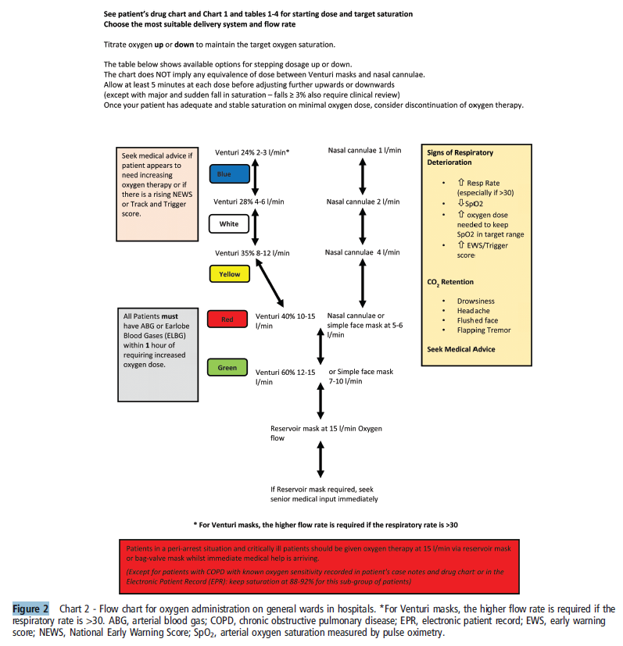

Appendix (j) PERSONNEL WHO MAY ADMINISTER OXYGEN
Any qualified nurse, doctor, RSCN, RN or physiotherapist. In accordance with policy for administration of medicines

Appendix (k) –Observation Chart and Device Codes*

*Insert an example of your local observations chart or NEWS chart here.
The device codes are standardised UK-wide

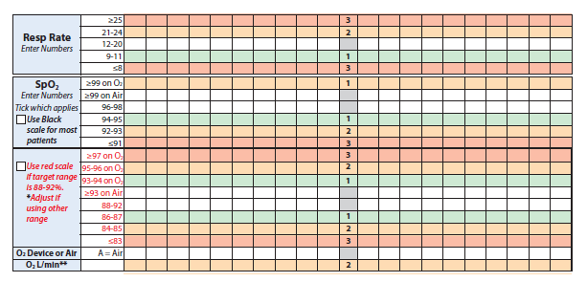

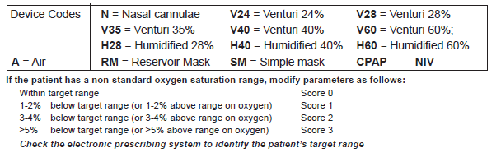

Appendix (l) MONITORING OF PATIENTS See Trust policy and NEWS system

ACTION | RATIONALE
- Observe the following;  a. Monitor arterial oxygen saturation levels according to Trust 0xygen policy.  b. Visual observations of skin colour for central cyanosis (blue lips).  c. Respiratory rate.  d. Any sign of respiratory distress should be reported immediately. | In order to accurately monitor the patient for signs of improvement or deterioration.
2. If the arterial oxygen saturation is above or below the target saturation the observer (often a Health Care Assistant) must inform the personnel who are qualified to administer oxygen (usually a Nurse – see appendix g). | Patient safety
3. Check the patients mouth and nose and behind the ears. | To identify signs of infection pressure sores as soon as possible.
4. Record all observations on appropriate Chart 4 hourly if on continuous oxygen 8 hourly if on intermittent oxygen | To ensure adequate record keeping.

Appendix (m) Salford modification of National Early Warning Score Salford NEWS; NEWS parameters and scoring system

*Insert an example of your local observations chart or NEWS chart here.

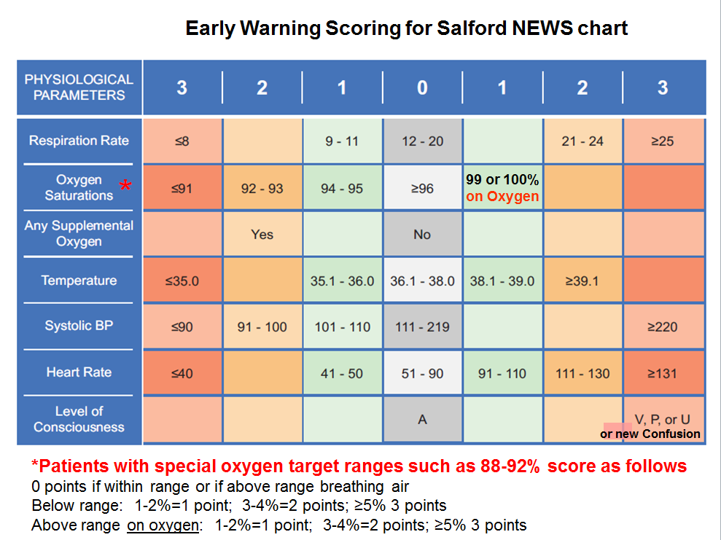

Appendix (n) HUMIDIFICATION

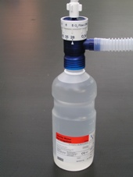

This should only be used if specifically requested by the doctor or physiotherapist in the following circumstances.

- If the flow rate exceeds 4 litres per minute for several days
- Tracheotomy or tracheostomy patients (“neck-breathing patients)”
- Cystic Fibrosis patients
- Bronchiectasis patients
- Patients with a chest infection retaining secretions

Can be given by warm or cold humidifier systems
(warm humidifier systems are mainly used in critical care areas)

Appendix (o) HEALTH AND SAFETY

1. Inform patients and carers about the combustibility of oxygen | Oxygen supports combustion, there.is always a danger of fire when oxygen is being used.
2. Oxygen should be stored in an area designated as no smoking.

3. Electrical appliances should be kept at least five feet away from the source of oxygen. | Oxygen can be potentially dangerous when in contact with sources of ignition and flammable material.
4. Avoid grease or oil coming into contact with apparatus.
5. Store unused cylinders in a dry well ventilated place.

Document Control Information

Policy for the Prescription and Administration of
Emergency Oxygen in Adults
Lead Author: *****
Consultant in Respiratory Medicine

Additional author(s):
***** Physiotherapist
***** Respiratory Nurse Specialist
***** Pharmacist
(Based on BTS Guideline for oxygen use in adults in healthcare and emergency setting 2017)
Document owner: *****
Contact details: *****
Classification: Clinical policy
Scope: Trust-wide
Applies to: All clinical staff
Document for public display: Yes
Keywords: Oxygen, oxygen therapy, oxygen masks, hypoxia, hypercapnia, hypoxaemia
Associated Documents:
Early warning score

Unique Identifier: ****
Issue number: ****
Replaces: **
Authorised by: Medicines Management Group
Authorisation date: **** 20167
Next review: Normally **** 2018

Policy Implementation Plan

All nurses, nursing assistants and other healthcare professionals involved in prescribing or administrating oxygen should be taught on the oxygen policy. Teaching aides are available on www.brit-thoracic.org/emergencyoxygen. A record of all those who have been taught will be kept.

All doctors should be taught about the oxygen policy. Teaching aids are available on the BTS website.

Monitoring and Review

The use of oxygen at **** Trust will be audited annually. (The hospital will participate in the national audits organised by the BTS) The results are discussed at the Respiratory Audit and Clinical Governance meetings, patient and staff feedback and monitoring or AIRS and SIARCs

Audits will be performed in all clinical areas. Audit proformas are available via the BTS website.

Oxygen champions in NHS Trusts to help introduce the Guideline. ***, *** and *** are the Oxygen Champions at *** Trust.

Endorsement

This table summarises the document ratification process.

Before submission of the document to a governance committee for final approval, endorsement by relevant stakeholders should be sought via a consultation process. This process should involve as many potential policy users as possible

Once the appropriate endorsements have been received and noted in the table below, the draft document should be sent to the appropriate committee's administrator to be added to the agenda for document approval.

All documents which have a Trust-wide or multi-divisional involvement must be ratified at Executive Governance level. There are several Executive Governance Committees – the most appropriate one will be determined by the nature of the document. Further advice is available in the Document Control Policy or from John Taylor (Document Control Administrator).

Endorsed by:
Name of Lead Clinician/Manager or Committee Chair | Position of Endorser or Name of Endorsing Committee | Date
 | Medicines Management Chair
 | Acting Principal Clinical Pharmacist

Screening Equality Analysis Outcomes

The Trust is required to ensure that all our policies/procedures meet the requirements of its service users, that it is accessible to all relevant groups and furthers the aims of the Equality Duty for all protected groups by age, religion/ belief, race, disability, sex, sexual orientation, marital status/ civil partnership, pregnancy/ maternity, gender re-assignment. Due consideration may also be given to carers & socioeconomic factors.

Have you been trained to carry out this assessment? no
If 'no' contact Equality Team 62598 for details.
Name of policy or document :

Policy for the Prescription and Administration of Emergency Oxygen in Adults

Key aims/objectives of policy/document:

Guidance for the safe and effective administration of oxygen therapy for all patients at **** NHS Trust

- a) Who is this document or policy aimed at? | 1a)  All staff responsible for prescribing and administration of oxygen therapy
2) a) Is there any evidence to suggest  that your ‘end users’ have different  needs in relation to this policy or  document; (e.g. health/ employment  inequality outcomes) (NB If you do not  have any evidence you should put in  section 8 how you will start to review  this data) | 2a) No
3) a) Does the document require any decision to be made which could result in some individuals receiving different treatment, care, outcomes to other groups/individuals? | 3a) No
b) If yes, on what basis would this decision be made? (It must be justified objectively) | 3b)
4) a) Have you included where you may need to make reasonable adjustments for disabled users or staff to ensure they receive the same outcomes to other groups ? | 4a) Additional training is provided for staff both face to face and via the internet
5) a) Have you undertaken any consultation/ involvement with service users or other groups in relation to this document? | 5a) These guidelines are an adaptation of National Guidelines developed over a 13 year period with consultation from numerous groups
b) If yes, what format did this take? Face/face or questionnaire? (please  provide details of this) | 5b)
c) Have any amendments been made as a result? | 5c)
- a) Are you aware of any complaints from service users in relation to this policy? | 6a) no
b) If yes, how was the issue resolved? Has this policy been amended as a result? | 6b)
7) a) To summarise; is there any evidence to indicate that any groups listed below receive different outcomes in relation to this document?

 | Yes |  | No | unsure
 | Positive | Negative*
Age |  |  | x
Disability |  |  | x
Sex |  |  | x
Race |  |  | x
Religion & Belief |  |  | x
Sexual orientation |  |  | x
Pregnancy & Maternity |  |  | x
Marital status/civil partnership |  |  | x
Gender Reassignment |  |  | x
Carers *1 |  |  | x
Socio/economic**2 |  |  | x
1: That these two categories are not classed as protected groups under the Equality Act.
2: Care must be taken when giving due consideration to socio/economic group that we do
not inadvertently discriminate against groups with protected characteristics
Negative Impacts
*If any negative impacts have been identified you must either a) state below how you have eliminated these within the policy or b) conduct a full impact assessment:

- How will the future outcomes of this policy be monitored?
• National Audit
• Review at the respiratory clinical governance meetings
• Staff and patient feedback
• AIRS and SIARCS
- If any negative impact has been highlighted by this assessment, you will need to undertake a full equality impact assessment:
Will this policy require a full impact assessment? No
(if yes please contact Equality Team, 62598/67204, for further guidance)

High/Medium/Low Type/sign: *******
date: **/**/2017

